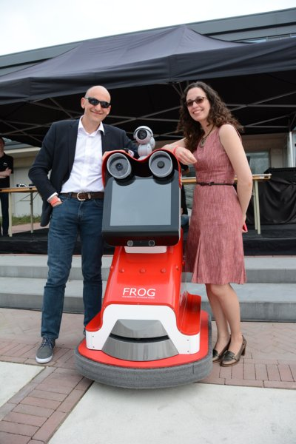
FROG, the Campus Robot

Researchers of the University of Twente have developed a unique, autonomous tour-guide robot as part of the project Fun Robotics Outdoor Guide (FROG):the campus robot. This robot is capable of exploring the environment and independently guiding groups of people around cultural places. At the same time he monitors the behaviour of his audience and adapts accordingly. This type of tour-guide robot is unique in the world.
The campus robot way of face recognition and navigation is innovative. He has an amusing personality and approaches visitors to interact with them. Where 'normal' tour-guide robots function as mobile audio guides - in a museum, for example -, the focus with the campus robot is on social interaction with a small group of people.
Professor Vanessa Evers, PhD, of the University of Twente explains: "the campus robot constantly enters into dialogue with his audience and is capable of recognizing positive and negative emotions. The current generation of tour-guide robots tend to see people mainly as obstacles when they navigate, their only concern being to avoid collisions with those people. They stand still to say something, and that's all they do. The campus robot actually focuses on interaction."
As of September, the campus robot will be on the University of Twente campus, where he will be guiding visitors. The robot displays social and entertaining behaviour and will introduce small groups of people to the Twente campus in an innovative way.

